
KS5 LTP

Key Stage 5 follows a two-year curriculum cycle centred around Preparation for Adulthood.
Learning is organised through six curriculum areas:
Independent Living
Personal Interests
Good Health
Friends, Family and Community
Communication
Computing & Digital Skills.
Students work towards greater independence, wellbeing, employability and community participation through practical, real-life experiences including travel training, cooking, enterprise, Duke of Edinburgh, Arts Award, Sports Leadership, Esports, Bike Maintenance and Outdoor Environment projects.
Learning is personalised through Pathways 1-3 and supports students to move confidently towards further education, employment, supported internships or adult services.

Across the three pathways there are multiple elements that we hope all students will leave BBS with
These are identified in the images below –
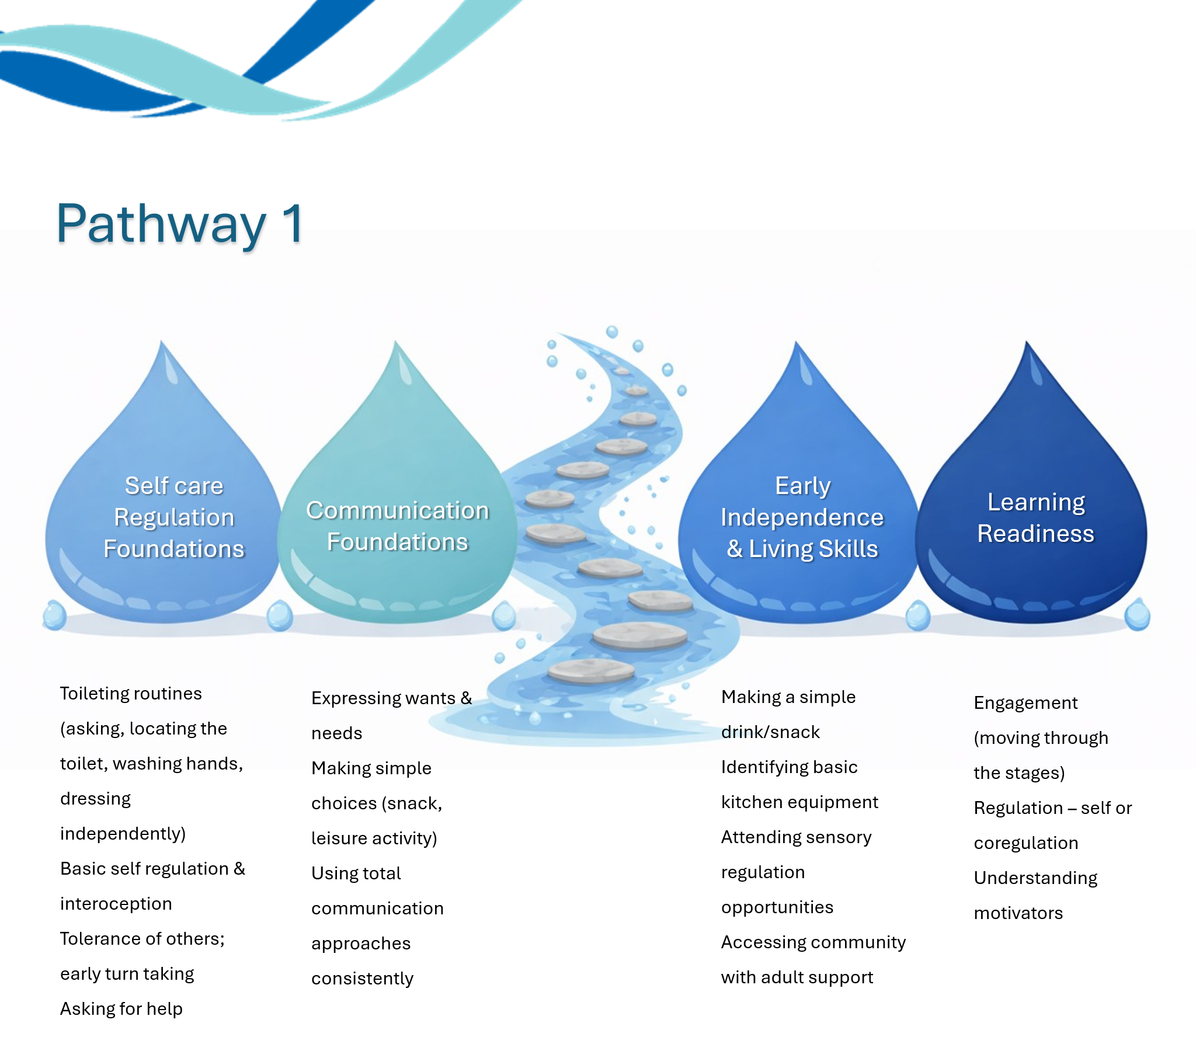
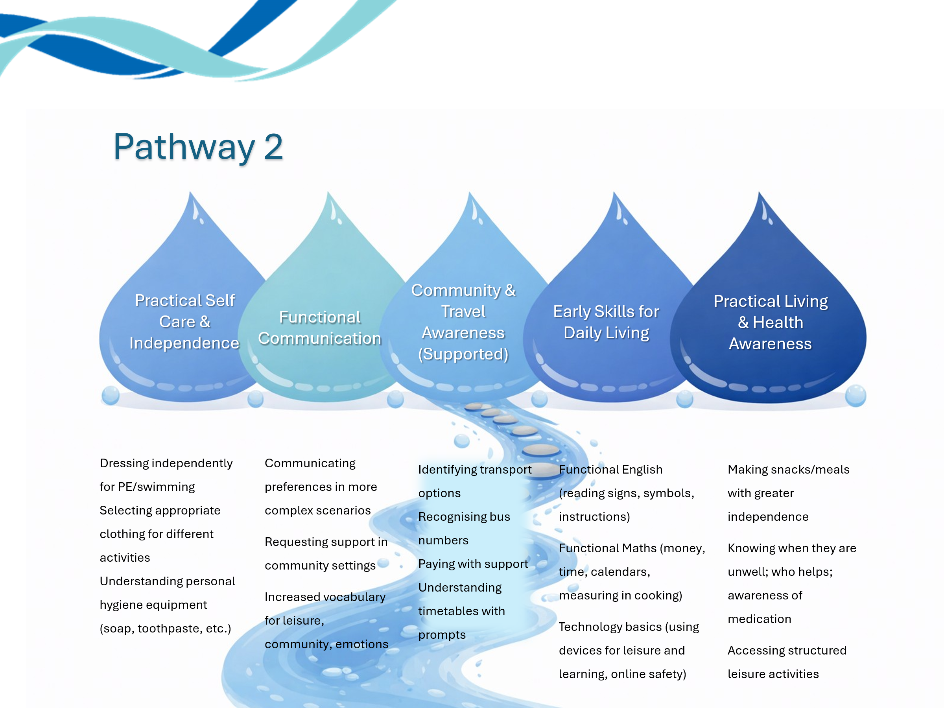
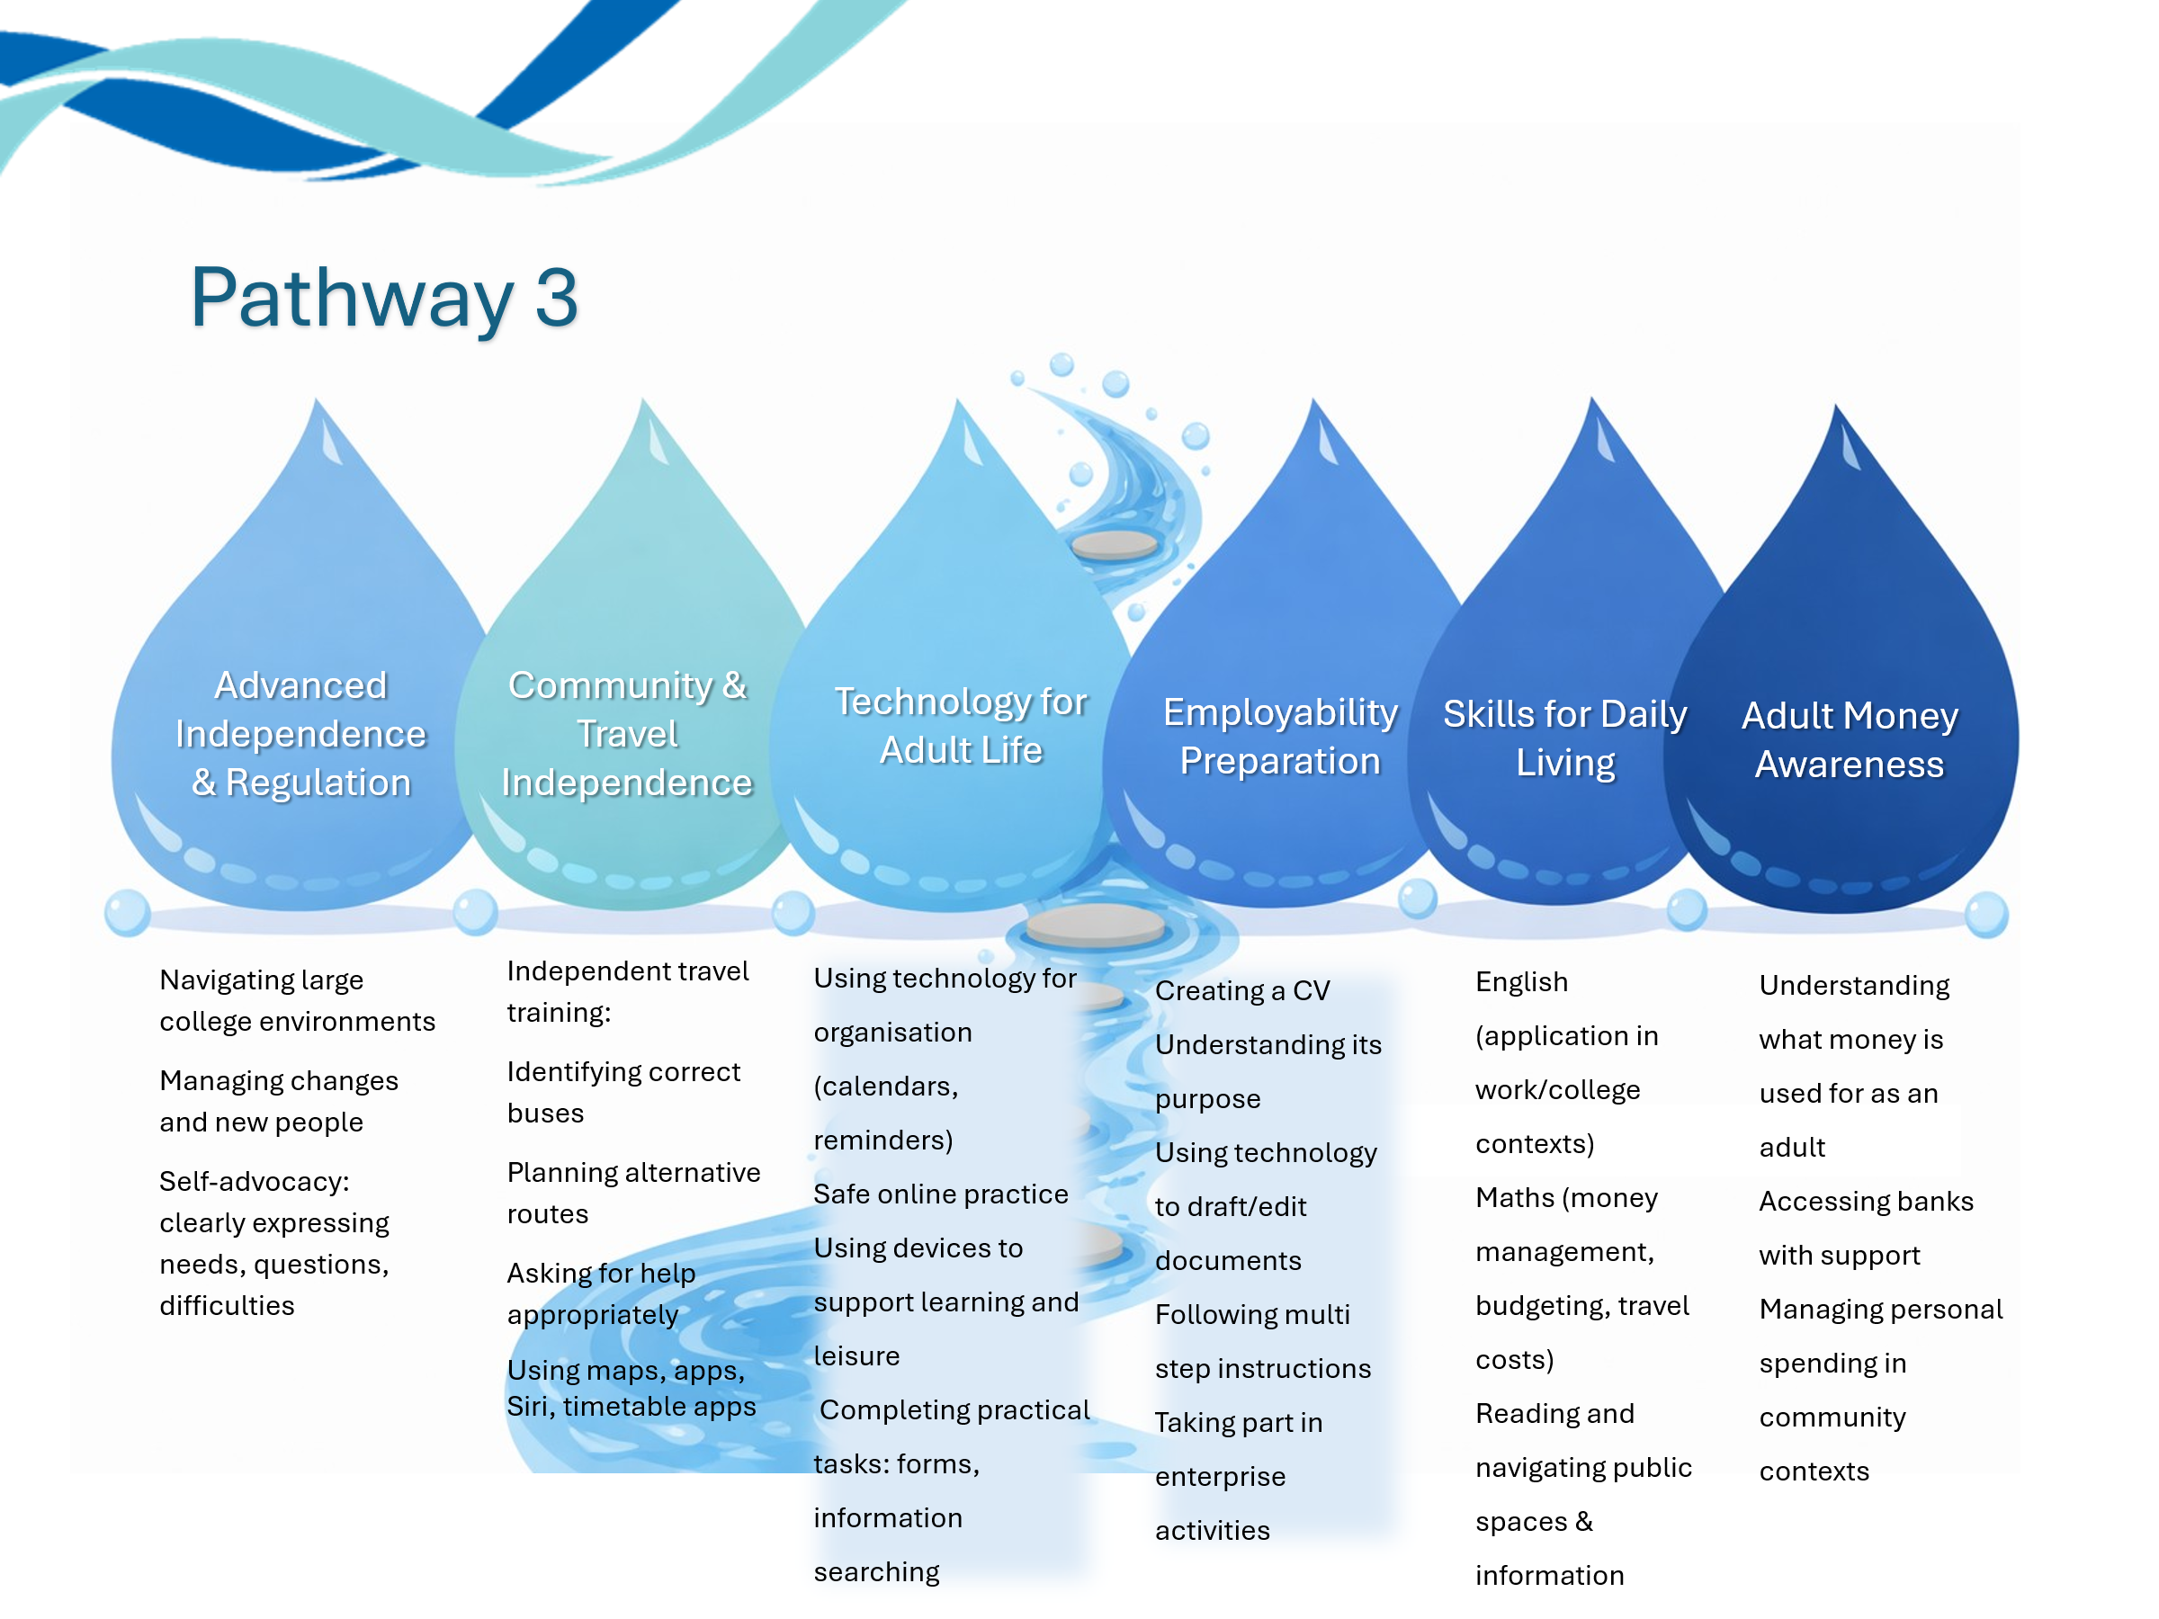

KS5 Long Term Plan
For the areas being covered, this would be skills and areas of focus for each element.
Year A
Independent Living | Personal Interests & Enterprise | Good Health | Friends, Family & Community | Communication | Computing & Digital Skills
Budget to Plate: meal planning, kitchen safety, food preparation | Sports Leadership: teamwork, leadership qualities | Self-awareness, aspirations, careers | Community awareness and local services | Functional English and Maths for life | Digital basics and device use
Household skills, laundry, home management | Bike maintenance and cycling safety | Personal safety, first aid, online safety | Travel awareness and road safety | Reading environmental print | Cyber security and data protection
Shopping, budgeting, comparison shopping | Arts Award: participation and skill development | Relationships, friendships and consent | RE/Citizenship: identity and belonging | Speaking and listening in community situations | Safe communication online
Cooking for others and healthy eating | Esports and digital creativity | Emotional wellbeing and regulation | Community participation projects | Communication for work and volunteering | Digital collaboration
Independent travel linked to shopping and appointments | Outside Environment: gardening and sustainability | Healthy lifestyles and exercise | DofE volunteering and community action | Functional literacy in real contexts | Online research and information checking
Preparing for transition and future destinations | Enterprise project | Mental health and wellbeing | Community celebration and volunteering | Presentation and reflection skills | Digital portfolios and evidence gathering

Year B
Independent Living | Personal Interests & Enterprise | Good Health | Friends, Family & Community | Communication | Computing & Digital Skills
Independent living pathways and adult services | Careers and Prince's Trust / King's Trust | Transition to adulthood | Rights, responsibilities and citizenship | CV writing and interview preparation | Productivity software
Managing money and banking | Sports Leadership: planning and leading activities | Safety in the workplace and community | Travel training and public transport | Workplace communication | Digital footprint and scams
Meal preparation on a budget | Arts Award: artist research and event review | Healthy relationships | Diversity, equality and inclusion | Self-advocacy and confidence | Online identity and reputation
Maintaining a home environment | Esports leadership and teamwork | Sexual health and consent | Independent community access | Communication in unfamiliar situations | Digital media creation
Managing appointments and personal organisation | Bike maintenance and route planning | Drug, alcohol and health education | Community navigation and problem-solving | Formal communication for adulthood | Online transactions and budgeting
Preparation for next placement, FE or employment | Enterprise showcase and celebration event | Lifelong wellbeing planning | Independent participation in community life | Reflecting and presenting achievements | Technology for adult life

Personal Interests –
Students will be provided with multiple opportunities to develop their personal interests; where they fall within the following areas, this is what they may cover within the two-year cycle
Sports Leadership | Outside Environment | Cycling and Bike Maintenance | Arts Award | Esports & Digital Creativity
Teamwork and communication  Leadership qualities  Inclusion in sport  Planning activities  Leading warm-ups  Evaluating performance | Garden safety  Tool identification  Planting and growing  Composting  Site maintenance  Environmental awareness | Helmet fitting and safety  Naming bike parts  Bicycle safety checks  Basic bike care  Balance and control skills  Group cycling | Participate in the arts  Explore art forms  Develop personal skills  Record achievements  Review performances/events  Reflect on learning | Team communication  Responsible gaming  Digital citizenship  Game design appreciation  Team roles and collaboration  Online safety
Coaching skills  STEP principle  Inclusive sports leadership  Organising events  Peer mentoring  Community sports participation | Garden planning  Sustainable projects  Seasonal maintenance  Habitat creation  Independent grounds maintenance  Community environmental projects | Route planning  Highway Code  Advanced cycling skills  Repairs and adjustments  Independent maintenance  Community cycling routes | Research artists  Develop advanced skills  Share skills with others  Lead a workshop/activity  Build a portfolio  Complete accreditation evidence | Leadership and strategy  Commentary and presentation  Tournament organisation  Content creation  Digital problem-solving  Technology for employability

English for everyday life  Year A | This is me  Focus on students exploring and express their unique identities, strengths, and aspirations through communication and presentation/ writing | Give a gift  Focus: to plan, create, and present meaningful gifts, developing functional communication and life skills in the process | My Day, My Way  Focus: students will build confidence in managing time, communicating needs, and making informed choices. This theme encourages ownership of learning and promotes skills essential for everyday life and future pathways. | My Place in the World  Focus: students will develop a sense of belonging, build communication skills, and apply these in real-life contexts | It’s my life  Focus: students will explore their interests, set goals, and build the communication and numeracy skills needed for independent living and adulthood | Stepping into tomorrow  Focus: prepare learners for their next steps in life—whether that’s further education, employment, or independent living
Kings Trust units | Preparing for the World of Work  Exploring strengths, skills, aspirations and identity links to identifying personal skills, workplace behaviours and suitable career options. Learners can produce profiles, CV starters, interviews and presentations. | Undertaking an Enterprise Project  Learners can design, make, market and present a gift product. Supports market research, planning, marketing resources, communication and project review. | Project-Based Learning  Focus on planning, organising routines, researching interests, presenting outcomes and reflecting on achievements aligns closely with project planning, delivery and review. | Project-Based Learning  Community research, local area investigations and presentations about meaningful places fit well with planning, delivering and reviewing a community-focused project. | Managing Money  Personal goals, life choices, aspirations, budgeting and financial independence align strongly with personal money management, needs vs wants and financial wellbeing. | Preparing for the World of Work  Preparing for employment, FE and adulthood directly matches job search skills, employment types, workplace expectations, payslips and career planning.
Suggested focus areas | Writing autobiographies, poems, or “All About Me” profiles.  Reading and responding to texts about identity and diversity.  Practising speaking and listening through presentations or interviews.  Developing functional writing (e.g. filling in forms, writing emails or CVs). | Writing/ creating cards, thank-you notes, or gift tags.  Creating persuasive writing (e.g. explaining why a gift is meaningful).  Reading and following instructions (e.g. recipes, craft guides).  Practising speaking and listening through presentations or group discussions. | Writing diary entries or daily journals.  Reading and following instructions (e.g. for morning routines or travel).  Practising speaking and listening through role-play or group discussions.  Writing and presenting a “My Perfect Day” plan.  Researching options for hobbies, college, life after school | Finding out/ Communicating about/ writing about their community, culture, or heritage.  Reading and discussing texts about different activities in their local area/ interest area.  Creating presentations or leaflets about a place that matters to them.  Practising speaking and listening through interviews or group discussions. | Writing personal statements, CVs, or goal-setting plans.  Reading and responding to texts about life choices and aspirations.  Practising speaking and listening through interviews or role-play.  Writing letters or emails related to real-life scenarios (e.g. job applications, appointments). | Writing/ creating CVs, cover letters, and personal statements.  Reading and interpreting adverts, application forms, posters, flyers and informational texts.  Practising conversations whether this is for leisure or work through role-play.  Communicating about future goals and creating vision boards or presentations.
Maths for Everyday life  Year A | This is me  Focus on students exploring and expressing their unique identities, information and health related info to support transition into adulthood | Give a gift  Focus on students planning, creating, and budgeting for meaningful gifts, developing functional maths and life skills in the process | My Day, My Way  Focus: Students will build confidence in managing time, communicating needs, and making informed choices. This theme encourages ownership of learning and promotes skills essential for everyday life and future pathways. | My Place in the World  Focus: students will develop a sense of belonging, build communication skills, and apply numeracy in real-life contexts | It’s my life  Focus: students will explore their interests, set goals, and build the communication and numeracy skills needed for independent living and adulthood | Stepping into tomorrow  Focus: prepare learners for their next steps in life—whether that’s further education, employment, or independent living
Kings Trust Units | Preparing for the World of Work  Personal information, timetables and data handling can support career exploration, employability and understanding workplace expectations. | Undertaking an Enterprise Project  Budgeting, pricing products, calculating costs, market research, profit and loss all have strong mathematical links. | Managing Money  Time management, budgeting for hobbies, planning activities and understanding spending choices link directly to personal budgeting. | Project-Based Learning  Route planning, transport costs, timetables, gathering information and presenting findings align with project delivery and evaluation. | Managing Money  Household budgeting, wants versus needs, payment methods, savings and financial decision-making fit perfectly within this theme. | Preparing for the World of Work  Payslips, wages, work schedules, National Minimum Wage, deductions and budgeting for independent living provide strong functional maths opportunities.
Maths focus | Measuring and comparing (e.g. “All About Me” statistics) height, weight, shoe size, clothes size  Using personal data (e.g. height, age, preferences) to create charts and graphs.  Number – recognising numbers linked to address, phone number, age, DOB, Post code  Time management and timetables (e.g. creating a weekly routine). | Budgeting for a gift (e.g. comparing prices, calculating totals and change).  Measuring and scaling (e.g. baking a treat, wrapping a present).  Time planning (e.g. creating a timeline for making or buying a gift).  Using money in real-life contexts (e.g. role-playing shopping scenarios)  Number and quantities | Creating and reading timetables or daily schedules.  Estimating and measuring time spent on activities.  Using time and money in real-life contexts (e.g. planning a journey or a shopping trip). Money – cost of hobbies, visiting places, preferences and interests being pursued. Budgeting – baking as an interest  Sequencing events and understanding durations. | Time – timetables, schedule and routines, distance time  Direction – location, route planning  Money – costs, budgeting, transport and entry costs, | Money - Financial education – wants vs needs  Budgeting for personal goals (e.g. saving for a hobby or event).  Time – time management, hours, days of the week, calendar, timetables for travel  Planning weekly routines using time and scheduling skills.  Understanding and using money in everyday contexts. | Time – routines and schedules  Planning and interpreting timetables (e.g. work shifts, college schedules).  Money – cost of hobbies, visiting places, preferences and interests being pursued.  Budgeting – continuation of budget to plate  Direction – location, route planning  Using information to compare options (e.g. travel routes, volunteer roles, classes and community groups).

English for everyday life  Year B | Knowing me  Focus on students recognising, remembering, and communicating key personal and health-related information that supports independence and safety in adulthood. | Time for a gathering  Focus on Christmas carols/ Christmas events planning and budgeting for this; refreshments and enterprise opportunities, gift budgeting to support exchanges | My Life, My Choices  Focus on building on “All About Me” by exploring likes/dislikes, routines, and personal choices (e.g. food, clothes, hobbies). | Out and about  Focus on community places, planning, distances, leisure, route timetables, taxi prices, events and entry costs | You’re hired!!  Focus: students will explore job roles, practise applying for work or volunteering, and build confidence in presenting themselves; | My next chapter  Focus on opportunities for life outside of school – leisure, filling their time, cost, budgets, meal planning, routes, locations
Kings Trust units | Personal Development  Learners explore strengths, achievements, areas for improvement and future goals through autobiographies, journals, discussions and personal profiles. | Presentation Skills  Planning and presenting Christmas events, invitations, menus and reviews provides authentic opportunities to prepare, deliver and evaluate presentations. | Personal Development  Focus on decision-making, independence, goal setting and self-reflection directly supports personal development planning and reviewing progress. | Community Impact  Investigating community facilities, services and local opportunities aligns with understanding community needs and participation. | Career Planning  Direct match with CV writing, application forms, interview preparation and career exploration. | Career Planning + Presentation Skills  Transition planning, presenting future aspirations and showcasing achievements align with career pathways and presentation skills.
Suggested focus areas | Writing “All About Me” profiles, poems, or autobiographies.  Reading texts about identity, emotions, and self-expression.  Practising speaking and listening through sharing personal stories or interviews.  Writing reflections or journals about their learning and goals. | Writing invitations, menus, or thank-you notes.  Reading and following instructions (e.g. recipes, event plans).  Practising speaking and listening through group planning and presentations.  Writing/ creating/ presenting reflections or reviews of the event. | Writing/ presenting/ communicating reflections, decision logs, or personal goal plans.  Reading and discussing texts about interests/ hobbies/ decision-making and independence.  Practising speaking and listening through role-play, and group discussions.  Writing letters, emails, or forms related to real-life choices (e.g. housing, college, work). | Reading signs, instructions, and public information.  Writing shopping lists, itineraries, or reviews of places visited.  Practising speaking and listening through role-play (e.g. asking for help, ordering food).  Reading leaflets, menus, or travel guides. | Writing CVs, cover letters, and job applications.  Reading and interpreting job/ volunteering adverts and workplace documents.  Practising interviews and workplace conversations through role-play.  Creating presentations or portfolios to showcase skills and achievements. | Writing/ presenting/ communicating personal statements, CVs, and application forms.  Reading and interpreting information about future pathways.  Practising interviews and conversations/ communication through role-play.  Reflecting through journals, letters to future self, or presentations about successes and strengths
Maths for everyday life  Year B | Knowing me  Focus on students recognising, remembering, and communicating key personal and health-related information that supports independence and safety in adulthood. | Time for a gathering  Focus on Christmas carols/ Christmas events planning and budgeting for this; refreshments and enterprise opportunities, gift budgeting to support exchanges | My Life, My Choices  Focus on building on “All About Me” by exploring likes/dislikes, routines, and personal choices (e.g. food, clothes, hobbies). | Out and about  Focus on community places, planning, distances, leisure, route timetables, taxi prices, events and entry costs | You’re hired!!  Focus: students will explore job roles, practise applying for work or volunteering, and build confidence in presenting themselves; | My next chapter  Focus on opportunities for life outside of school – leisure, filling their time, cost, budgets, meal planning, routes, locations
Kings Trust units | Personal Development  Measuring personal data, using timetables, analysing strengths and tracking targets through graphs and data collection. | Presentation Skills  Event budgeting, guest numbers, timings, schedules, refreshments and presenting financial information. | Personal Development  Budgeting, planning routines, managing hobbies and making informed financial decisions. | Community Impact  Calculating travel costs, route planning, distances, timetables and resource planning for community activities. | Career Planning  Understanding wages, pay scales, work schedules, shift patterns, travel costs and job-related budgeting. | Career Planning  Comparing colleges, training routes, travel options, living costs and future financial planning.
Maths focus | Measuring and comparing (e.g. “All About Me” statistics) height, weight, shoe size, clothes size  Number – recognising numbers linked to address, phone number, age, DOB, Post code  Location – direction, bus routes,  Time management and timetables (e.g. creating a weekly routine). | Money – budgeting  Time – planning, calendars, days of the week  Number – quantity of people, invites | Time – routines and schedules  Money – cost of hobbies, visiting places, preferences and interests being pursued. Budgeting – baking as an interest | Time – timetables, schedule and routines, distance time  Direction – location, route planning  Money – costs, budgeting, transport and entry costs, | Money - Financial education – wants vs needs  Time – time management, hours, days of the week, calendar, timetables for travel  Using timetables and rotas (e.g. shift patterns, travel to work).  Handling money in workplace scenarios (e.g. retail, hospitality). | Time – routines and schedules  Money – cost of hobbies, visiting places, preferences and interests being pursued.  Budgeting – continuation of budget to plate Direction – location, route planning

Online safety
 | Autumn 1 | Autumn 2 | Spring 1 and 2 (2 shorter terms) | Summer 1 and 2
2026-27 | Conduct  How should I behave, on and offline?  - Transition  - Whatsapp groups  - VPN use  - Falling out  - Screen time | Commerce  How can I keep my money safe?  - Subscriptions  - Value of money (could use Maths objectives)  - Microtransactions  - Buying online safely (link to Christmas)  - Tiktok shop  SOCIAL MEDIA BAN SPRING 2027 – EXPLAIN WHAT THIS WILL INVOLVE. PREPARE PUPILS FOR ANY CHANGES IN SPRING TERM | Content  What is it safe to see and to share?  - AI – recognising real and fake  - AI – use of chatbots  - Early Warning signs + Protective Behaviours  - Sending nudes  - Impact of Social Media ban | Contact  Who is it safe to share with online?  - Links with So Safe  - Keeping in touch safely after transitions  - Gaming chats  - Sending nudes
2027-28 | Conduct  How should I behave, on and offline? | Contact  How can I keep my money safe? | Content  What is it safe to see and to share? | Contact  Who is it safe to share with online?

Nb – Bullet points are only suggestions, which are related to issues that have arisen in KS5 in recent years, are good cross-curricular things to note, or are emerging issues. They are not mandatory and will not be appropriate for all pupils, but are meant as suggestions for contexts for discussion, particularly for Pathway 2/3 pupils.

